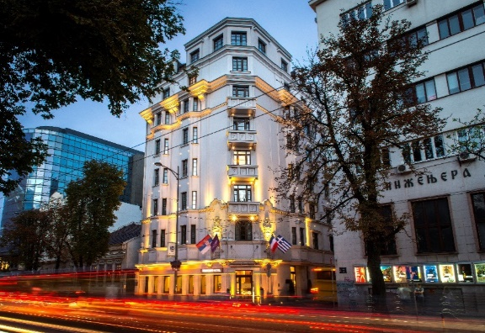

**Reservation Form for**

**Kovilovo 2025 Event**

**26.08-08.09.2025.**

**With MERCURE Belgrade Excelsior Hotel**

First Name: ____________________ Last Name: _________________________

**Room type with buffet breakfast - BB:**

Superior room single use 99  Superior room double use 112 $EUR$

*\*****The Superior room can be booked either with a king-size bed or two separate twin beds.***

**Room rates include: Bed and Breakfast,** VAT, Wireless internet in the room and public area.

**Room rates exclude**: City tax which is 1.40 EUR per day, per person.

**Arrival Date:** 8/26/2025  **Departure Date**: 9/8/2025

(Check-In Time from 15:00) (Check-Out Time until 12:00 noon)

Reservation guarantee: No reservations will be confirmed nor guaranteed unless credit card details are provided.

**Credit card type/name:** Visa **Credit card number:**___________________

**Expiration date:** ___/_______________ **Card holder name:**  __________________

By signing this, I guarantee the above booking to this credit card and accept the terms of cancellation below.

**Signature of cardholder:** ___________________________________

By signing this I guarantee the above booking to this credit card and accept the terms of cancellation:

Guests will pay all expenses directly in hotel by their credit cards.

Reservation form with credit card details will be used for hotel accommodation/reservation guarantee.

Reservations can be modified or cancelled up to 5 days prior the arrival date. For every reservation cancelled after mentioned deadline, the guest will be charged for the full amount of the stay.

In case of guest’s non-arrival (i.e. no show), the guest will be charged for the full amount of the stay.

**Please send the completed form to Sales Department at following email:** [mina.pesic@accor.com](mailto:mina.pesic@accor.com)

We are offering transfer service for our valued guests at following surcharge:

• Transfer with business-class auto at a price of 45 EUR (including VAT) in one direction for a maximum of 3 passengers.

• Transfer with minivan at a price of 70 EUR (including VAT) one way for a maximum of 6 passengers.

• Our car equipped with wireless Internet. All necessary reservations, together with flight details, must be submitted no later than 24 hours before arrival.

Looking forward to welcoming you to our hotel,

Sales Department

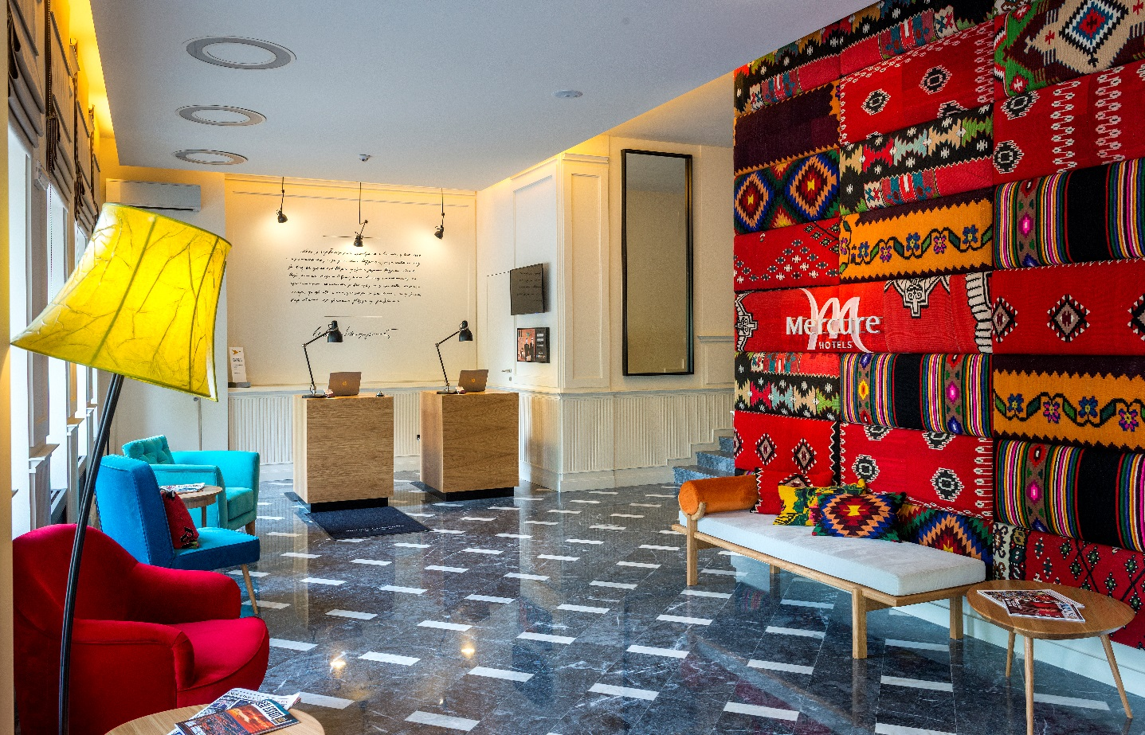

**Superior room with king size bed Superior room with twin beds**

